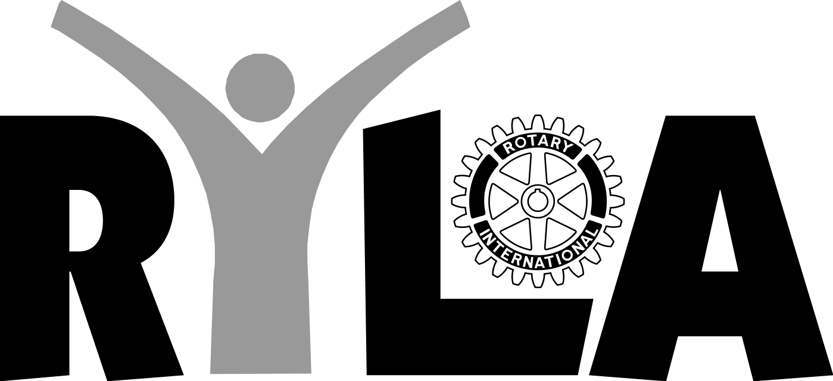
2019 Hawai`i Island Rotary Youth Leadership Awards Camp
February 15-17-, 2019, KMC, Volcano, HI
What To Bring - Besides Your Wonderful Self!
IMPORTANT! - Please label all belongings!
Clothes
- 1 rubber slippers (for showers)
- 1 pair LONG shorts*
- 2 pair jeans/sweatpants*
- 2 pairs of socks
- 2 t-shirts*
- 1 jacket/sweatshirt! Volcano can get very cold so please be prepared.
- 1 baseball cap when working outside for the service project
- 2 pairs of underwear
- Running shoes/cross trainers for outdoor activity and working outside
- Jammies OR pareau

* Old ‘kine’ beat up OK

Personal Stuff / Hygiene Kit
- Shampoo, soap & deodorant (please)
- Toothbrush, tooth paste & contact lens solution
- One (1) light weight bath towel/wash cloth,
- Sunscreen, insect repellent, feminine products.
- Medication
- Flashlight with new batteries

(RYLA Camp does not distribute aspirin, pain relief pills or over the counter drugs - please bring what your parents allow you to consume).

Optional
- Musical instruments (please share your talents!)
- Film cameras, digital cameras
Kapu (Leave at Home)
- Snacks (unless you can provide for the entire Ohana)
- Audio/Video equipment and components
- Electronic games, personal planners, personal audio players, DVD players, laptops etc.
- Heirloom jewelry (no need for fancy stuff), money, moolah, cash (nothing to buy)
- Cellular phones and beepers (You may use our phones for emergencies.)

